*Create table and do the following questions*

1. Create table name as trainee
2. Insert values into the table in given question
3. 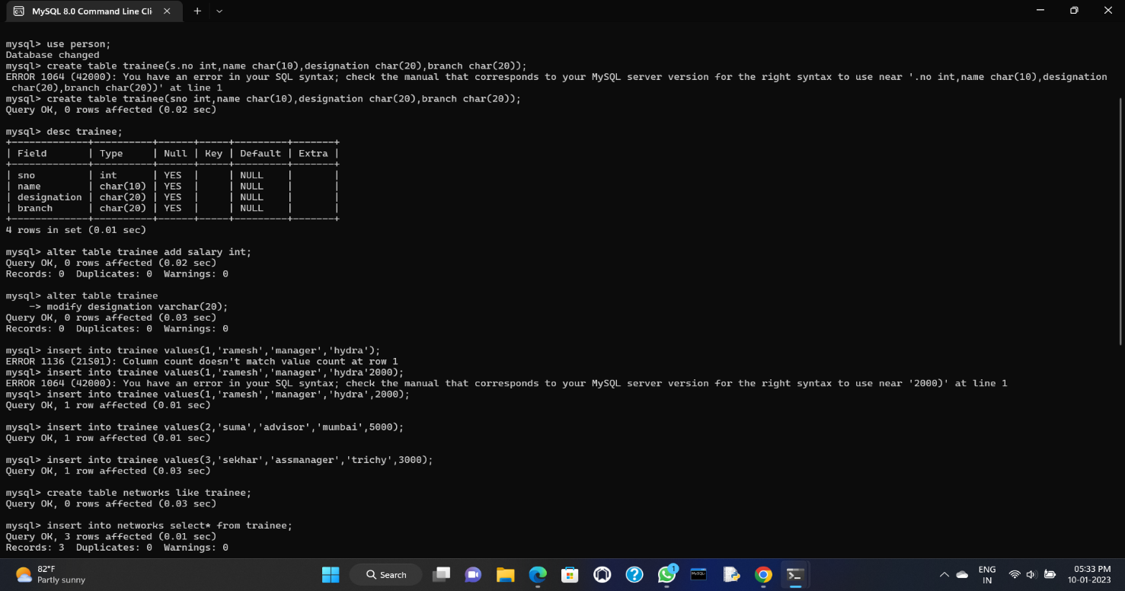To add the column of the salary
4. Alter modify the table designation
5. Then describe the table trainee
6. Copy same as networks
7. Then delete the second row in the table
8. 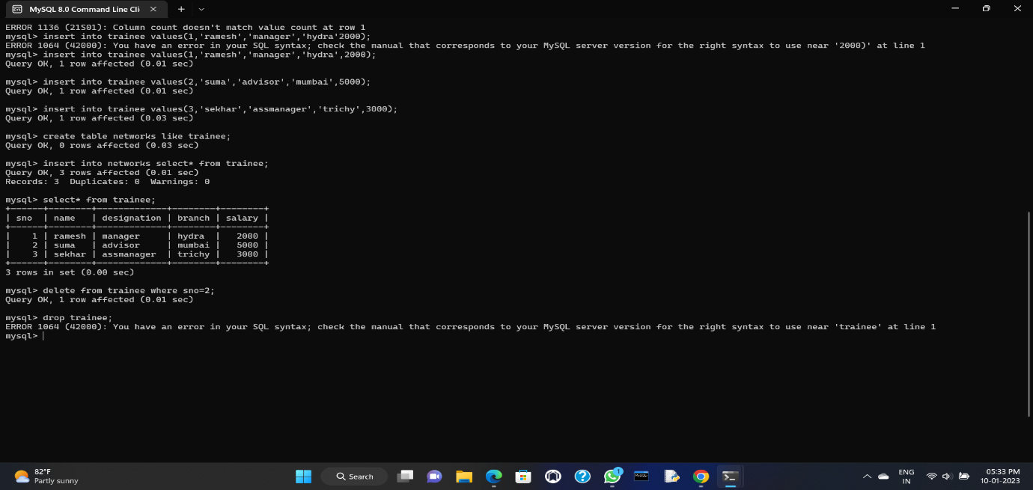Then drop the table